1. **What is Boolean?**

* A Boolean is a value that can be True or False and the Python type is bool.

**3 different expressions that results a Boolean type:**

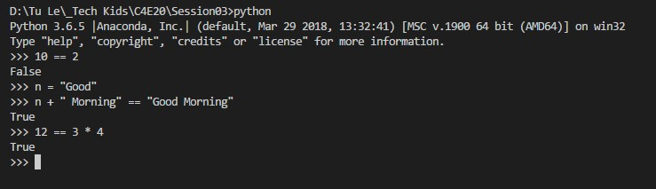

1. **What is flow chart?**

* A **flowchart** is a type of diagram that represents an algorithm, workflow or process. The **flowchart** shows the steps as boxes of various kinds, and their order by connecting the boxes with arrows. This diagrammatic representation illustrates a solution model to a given problem.

**Draw flowchart:**

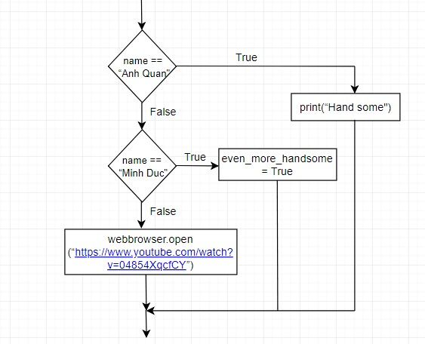

1. **What is nested conditionals?**

It is the conditionals that one conditional is nested within the other.

**Piece of code that that uses nested conditionals:**

x = int(input("Please insert a number: "))

if x % 2 == 0 and x > 0:

print("This is a positive even number")

